Name | Rohitkumar Bhoga
Roll no | 24204B0062
Batch | 3
Subject name | Python Programming & Data Structure
Teacher Name | Ms. Rasika Patil

Experiments | 2
Title | - Develop python program to check whether the entered frequency is radio frequency or audio frequency.  - Develop python program to display various radio frequency bands using if..elseif ladder.  - Develop python program to display resistor color code using switch statement.
Theory
Decision-making in Python uses conditional statements such as if, elif, and else to control program flow.
In this practical, students classify frequencies as Audio Frequency (AF) or Radio Frequency (RF), identify RF bands, and implement resistor color code logic.

Syntax
• if condition:
• elif condition:
• else:
• Comparison operators: < > == != >= <=

Simple If Statement: A simple `if` statement is used to execute a block of code only if a specified condition is true. If the condition is false, the block of code inside the `if` statement is skipped.

Syntax:
if condition:
code to execute if condition is true

Example:
age = 18
if age >= 18:
print("You are eligible to vote.")
In this example, the message "You are eligible to vote." is printed only if the `age` is 18 or older. If-Else Statement: An `if-else` statement is used to execute one block of code if the condition is true, and another block of code if the condition is false.
Syntax: | Example:
if condition:  # code to execute if condition is true else:  # code to execute if condition is false | age = 16  if age >= 18:  print("You are eligible to vote.") else:  print("You are not eligible to vote.")
In this example, the message "You are not eligible to vote." is printed because the `age`
is less than 18.

Nested If Statement
A nested `if` statement is an `if` statement inside another `if` statement. This allows for more complex decision-making and multi-level condition checking.
Syntax: | Example:
if condition1:  # code to execute if condition1 is true if condition2:  # code to execute if both condition1 and condition2 are true | age = 20 has_id = True if age >= 18:  if has_id:  print("You are eligible to enter the club.") else:  print("You need an ID to enter the club.") else:  print("You are not old enough to enter the club.")
In this example, the message "You are eligible to enter the club." is printed because both conditions (`age >= 18` and `has_id`) are true. If `has_id` were `False`, the message "You need an ID to enter the club." would be printed instead.

Programming Questions with Answer
1 | Write a program to check whether entered frequency isradio frequency or audio frequency.
SCRIPT | 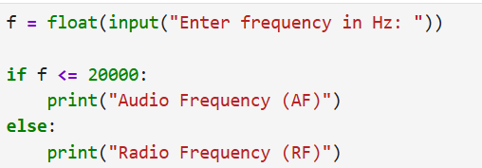
OP | 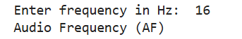
2 | Program to display RF bands using if–elif
SCRIPT | 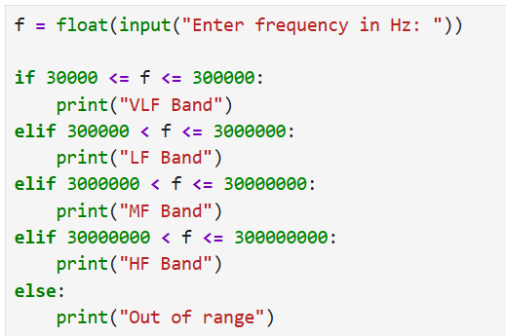
OP | 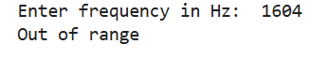
3 | Program for resistor color code using selection logic
SCRIPT | 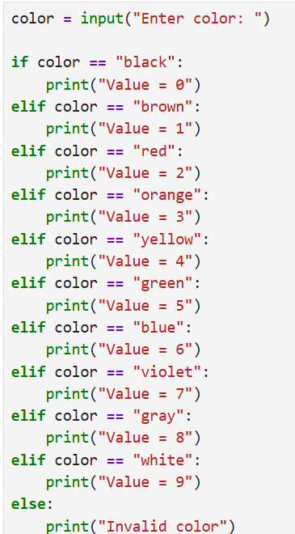
OP | 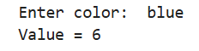
4 | Write a Python program that checks if the voltage of a battery is greater than 3.7V and prints "Battery is charged" if true.
SCRIPT | 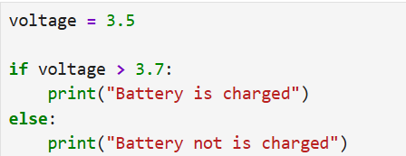
OP | 
5 | Write a Python program that checks if a resistor value is within a tolerance range (e.g., 5% tolerance for a 100Ω resistor) and prints whether it is within tolerance or not.
SCRIPT | 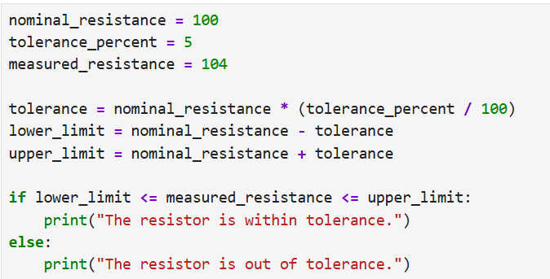
OP | 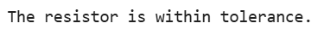
Debugging Questions with Corrected Answers
1 | Debug the following code  Wrong code:  f = float(input("Frequency: "))  if f < 20000  print("AF")  else  print("RF")
OP | Error:  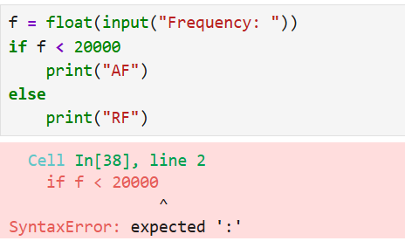  Correct code: 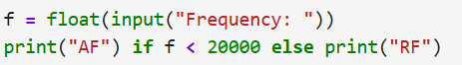  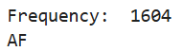
2 | Debug the following code  Wrong code:  clr = input("Color: ")  if clr = "red":  print(2)
OP | Error: 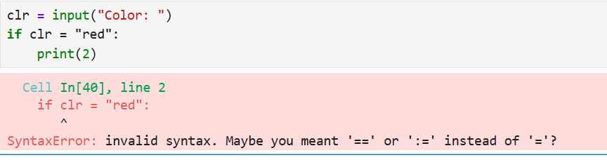  Correct code:  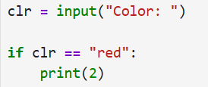  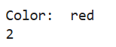
Conclusion

Performance Indicators |  | Teachers Dated and Signature
Process Related  (15 M) | Product Related  (10 M) | Total (25 M)

